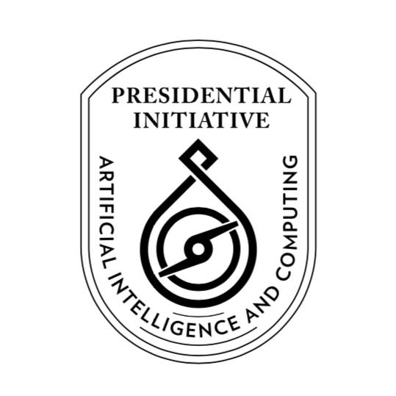

**Presidential Initiative for Artificial Intelligence and Computing (PIAIC)**

https://www.piaic.org

**Artificial Intelligence Specialist Program**

Course Syllabus

**Quarter II: AI-201 Data Analysis and Introduction to Deep Learning**

Version 1.0.0 - 2020 (12 Weeks)

**Teaching Team: Inam Ul Haq, Dr. Noman Islam, Anees Ahmed, Nasir Hussain, Muhammad Qasim, Khurram Raheel, Waqas Ali Munawar, Muhammad Ali, Muhammad Hamza Khan, Aqsa Abdul Qadir, Fayyaz Farooq, Gulraeez Gulshan, Hafiz Muhammad Shahid, Jalees Ur Rehman Khan, Komal Aftab, Mansoor Hussain, Mohsin Iqbal, Muhammad Ali, Muhammad Asadullah, Muhammad Hamza Khan, Muhammad Haseeb Amjad, Muhammad Shahzad Ahsan, Muhammad Sohaib, Muhammad Usman, Nehal Ahmed, Ramsha Munawarah Azeemi, Saqib Arfeen, Shafqat Soomro, Shifa-ur-Rehman Jamali, Syed Hamza, Syed Hamza Ali, Syed Muhammad Masab, Syed Wajahat Ali Naqvi, Umair Shahzad, Waqas Ali Munawar, Rauf ur Rahim, Faizan Amin, Tahir Bhatti, Adan Abid, and Arslan**

**Class Duration: 4 hours**

**Course Description:** In start the course by learning NumPy the backbone of scientific computing and used extensively with TensorFlow. NumPy will give you both speed and high productivity. Then we will walk you through Pandas with clear, step-by-step examples and just the right amount of theory. The first part of the course focuses on the fundamentals of NumPy and Pandas, including array objects, functions, and matrices, each of them explained with practical examples. In next part of the course will offer a practical, hands-on exploration of introduction to deep learning using Keras/Tensorflow 2.0. We will avoid mathematical notation, preferring instead to explain quantitative concepts via code snippets and to build practical intuition about the core ideas of machine learning and deep learning.

**Please bring a Laptop with you for the Classes (Required, but not mandatory)**

**Textbooks:**

1. [Python for Data Analysis by Wes McKinney 2nd Edition](https://www.amazon.com/Python-Data-Analysis-Wrangling-IPython-ebook/dp/B075X4LT6K/ref=sr_1_1)
2. [Deep Learning with Python by Francois Chollet](https://www.amazon.com/Deep-Learning-Python-Francois-Chollet/dp/1617294438/ref=sr_1_1)

**References:**

1. <https://www.tensorflow.org/>
2. [Hands-on Machine Learning with Scikit-Learn, Keras, and TensorFlow, 2nd Edition by Aurélien Géron](https://www.oreilly.com/library/view/hands-on-machine-learning/9781492032632/)

**PIAIC Announcements Facebook Group:** <https://www.facebook.com/groups/piaic/>

**Course Facebook Group:** <https://www.facebook.com/groups/deep.learning.edu/>

**Portal for online and onsite students:**

<https://portal.piaic.org/>

**Chat on Telegram:**

Group Name: PIAIC-AI

https://t.me/piaic_ai

**Grading:**

Students will be graded based on Percentile

<https://en.wikipedia.org/wiki/Percentile>

<https://en.wikipedia.org/wiki/Percentile_rank>

A-Grade: 78- 99 Percentile

B-Grade: 41- 77 Percentile

C-Grade: 23- 40 Percentile

D-Grade: 1 - 22 Percentile

F-Grade: Anyone who doesn’t appear in two or more exams

Note: Anyone who receives a F-Grade will be removed from the program. Students who receive a D-Grade will be put on probation, and be required to earn a grade of C or above in the next quarter, to remain in the program. Anyone absent from an exam will be deemed to have received a score of zero.

**Important Note:**

If a PIAIC candidate doesn’t appear in a Quiz at the scheduled time announced by management 10% score will be deducted from the test score for every week of delay.

**Course Outline:**

1. **Fundamentals of Version Control with Git**

(**Videos and reading material available on Student Portal to prepare for Git Quiz, Git will not be covered in class to save class time)**  
Chapters 1, 2, 3, and 4 Learn Version Control with Git: A step-by-step course for the complete beginner by Tobias Günther

We will also covers these readings:

<https://help.github.com/articles/markdown-basics/>

<http://stackoverflow.com/questions/5009600/difference-between-fork-and-branch-on-github>

<http://stackoverflow.com/questions/3329943/git-branch-fork-fetch-merge-rebase-and-clone-what-are-the-differences>

<https://git-scm.com/book/en/v2/Git-Branching-Rebasing>

<http://git-scm.com/book/en/v2/Git-Branching-Remote-Branches#Tracking-Branches>

For practice: <https://try.github.io/levels/1/challenges/1>

Homework:

<https://www.datacamp.com/courses/introduction-to-git-for-data-science>

**Git Quiz in Week 2**

Total Questions: 50, Total Time: 60 minutes

1. **NumPy Basics** (Week 1 and 2)

Chapter 4 and Appendix A Section a2 of Python for Data Analysis by Wes McKinney 2nd Edition

**NumPy Quiz in Week 3**

Total Questions: 36, Total Time: 60 minutes

1. **Getting Started with Pandas** (Week 3)  
   Chapter 5 of Python for Data Analysis by Wes McKinney
2. **Data Loading, Storage, and File Formats** (Week 4)  
   Chapter 6 of Python for Data Analysis by Wes McKinney
3. **Data Cleaning and Preparation** (Week 5)  
   Chapter 7 of Python for Data Analysis by Wes McKinney
4. **Data Wrangling: Join, Combine, and Reshape** (Week 6)

Chapter 8 of Python for Data Analysis by Wes McKinney

**Pandas Quiz in Week 6**

Total Questions: 36, Total Time: 60 minutes

1. **Introduction to Deep Learning Part 1** (Weeks 7)  
   Chapter 1 of Deep Learning with Python by Francois Chollet
2. **Introduction to Deep Learning Part 2** (Weeks 8 and 9)  
   Chapter 2 of Deep Learning with Python by Francois Chollet

**Deep Learning Quiz 1 in Week 9**

Total Questions: 55, Total Time: 75 minutes

1. **Introduction to Deep Learning Part 3** (Weeks 10 and 11)  
   Chapter 3 of Deep Learning with Python by Francois Chollet
2. **Introduction to Deep Learning Part 4** (Weeks 12 and 13)  
   Chapter 4 of Deep Learning with Python by Francois Chollet

**Deep Learning Quiz 1 in Week 13**

Total Questions: 55, Total Time: 75 minutes

1. **Deep Learning Project** (Week 13)

**François Chollet TensorFlow 2.0 Tutorial:** <https://colab.research.google.com/drive/1UCJt8EYjlzCs1H1d1X0iDGYJsHKwu-NO>